Assignment 4 –
Step 1 : Create an EC2 instance.
Step 2 : Create Role, given full S3 access to an EC2 instance.
Step 3 : attached role to an EC2 instance.
Step 4 : Install Java-17, tomcat-10 and Jenkins in an EC2
Step 5 : Login to Jenkins and create and configure jobs as per requirements
Shell Script :
#!/bin/bash
set -e

echo "Installing git if not installed"
yum install git -y

echo "Creating S3 bucket"
aws s3 mb s3://stat-web-host-23 --region ap-south-1

echo "Disable Block Public Access"
aws s3api put-public-access-block --bucket stat-web-host-23 --public-access-block-configuration '{
"BlockPublicAcls": false,
"IgnorePublicAcls": false,
"BlockPublicPolicy": false,
"RestrictPublicBuckets": false
}'

echo "Set bucket policy for public read"
cat <<EOF > policy.json
{
"Version": "2012-10-17",
"Statement": [
{
"Effect": "Allow",
"Principal": "*",
"Action": "s3:GetObject",
"Resource": "arn:aws:s3:::stat-web-host-23/*"
}
]
}
EOF

echo "Applying bucket policy"
aws s3api put-bucket-policy --bucket stat-web-host-23 --policy file://policy.json

echo "Enabling static website hosting"
aws s3 website s3://stat-web-host-23 \
--index-document index.html \
--error-document error.html

echo "Moving to Jenkins workspace"
cd $WORKSPACE

echo "Cloning repository"
git clone https://github.com/Deepika-777/Jenkins-Assignment-4.git

cd Jenkins-Assignment-4

echo "Uploading files to S3"
aws s3 sync . s3://stat-web-host-23

echo "Deployment successful"

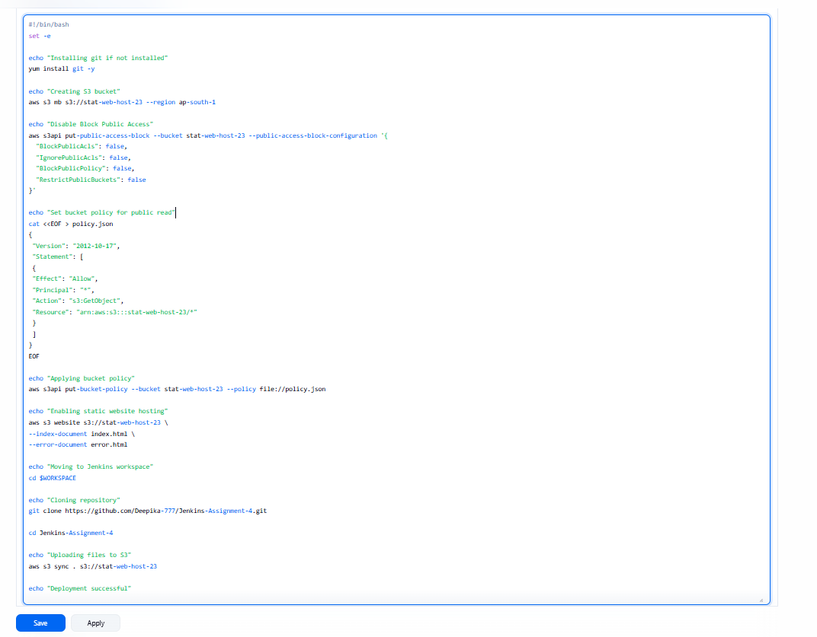

Step 6 : build the job successfully.
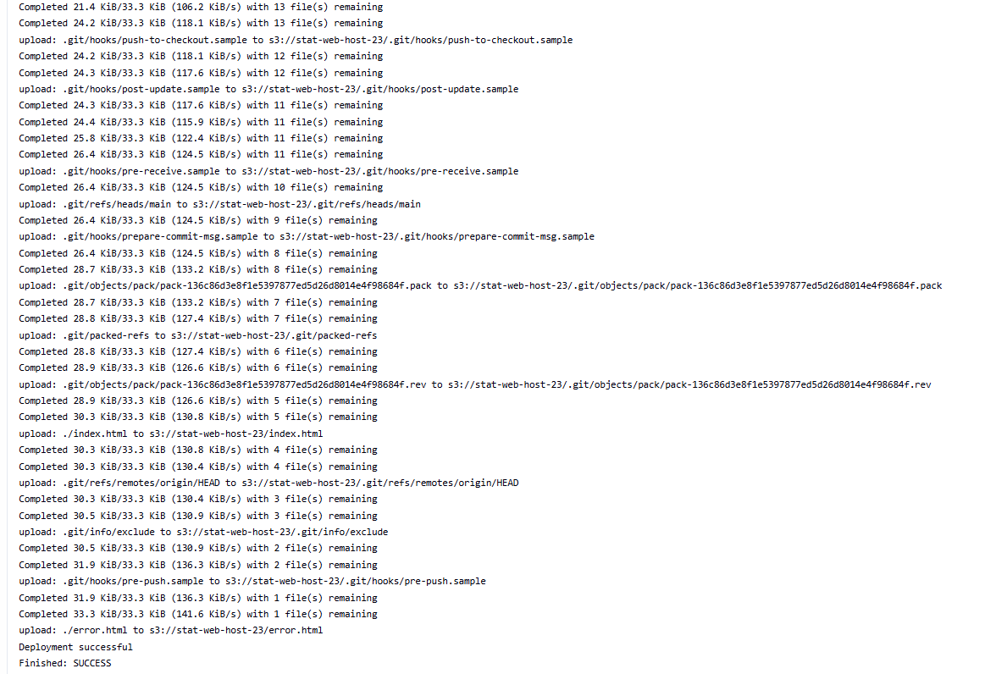

Step 7 : Checked output in S3-bucket
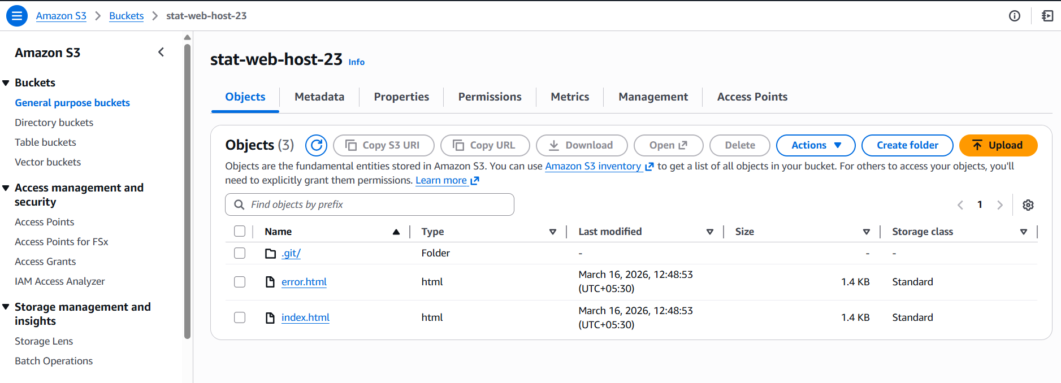

Step 8 : check http://stat-web-host-23.s3-website-ap-south-1.amazonaws.com

